SET UP:

1. Install python on your device
2. Check the version of the python
3. 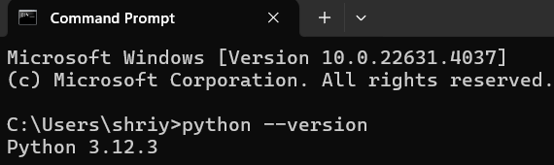Install Required Libraries

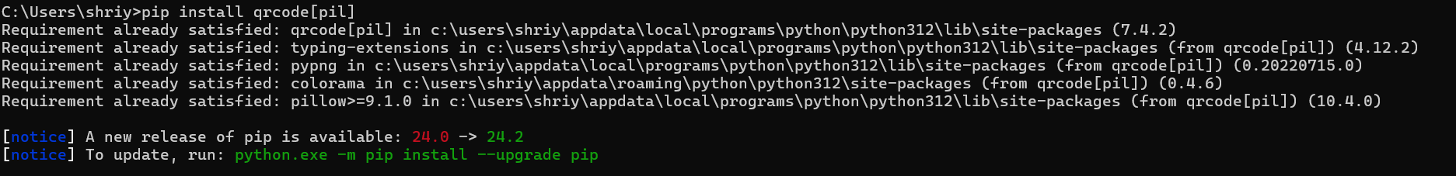First, you need to install the qrcode and Pillow libraries. You can do this using pip:

1. Create a Python Script

Create a new Python script, for example, ex_QR.py.

1. **Run Your Script**

Run your Python script from the command line:



1. Get the output as follows:

OUTPUT 1:

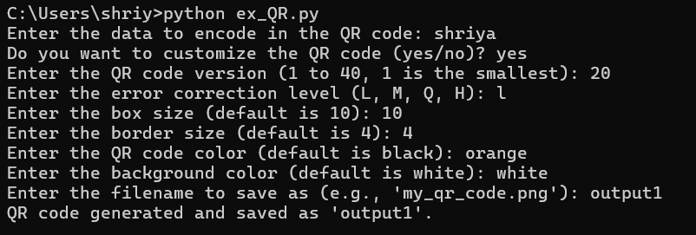

OUTPUT 2:

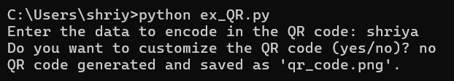

OUTPUT 3:

